CAPM (Cloud application programming model) Project
This is the Schema.cds for this Project
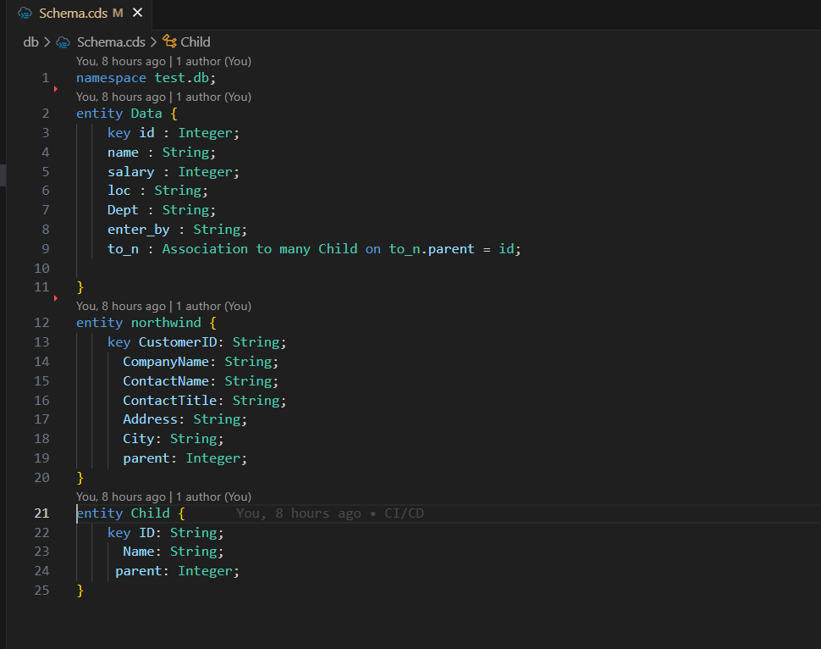

This is the Service.cds for this project
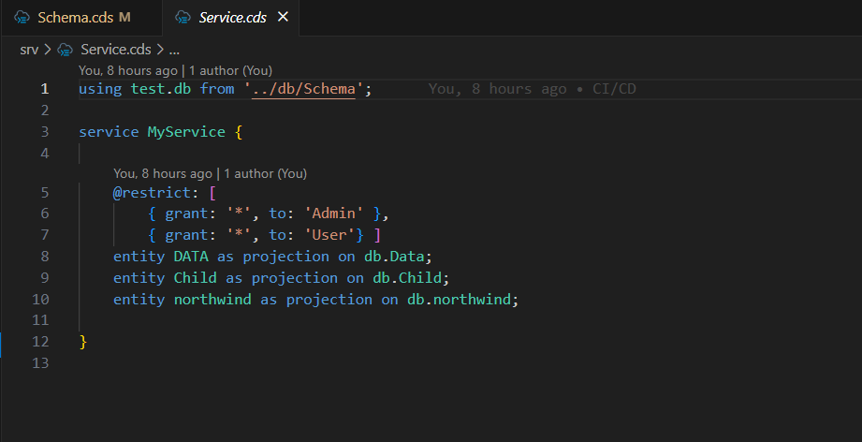

This is the Service.JS which is used to expose the north-wind API
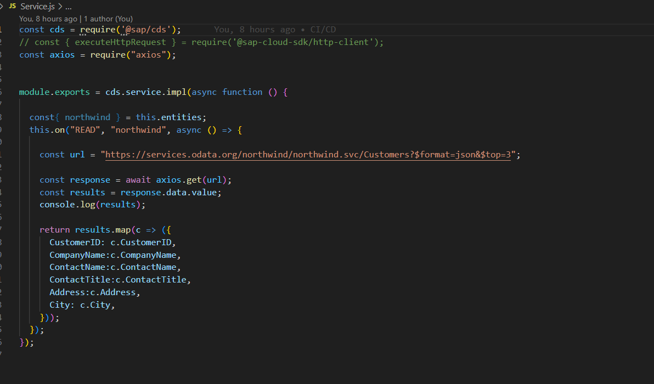

After that add the Fiori list report in the “SAP Fiori generator”
this will generate the annotations.cds file modify it to get the data as needed the output for this is as below

--List Page
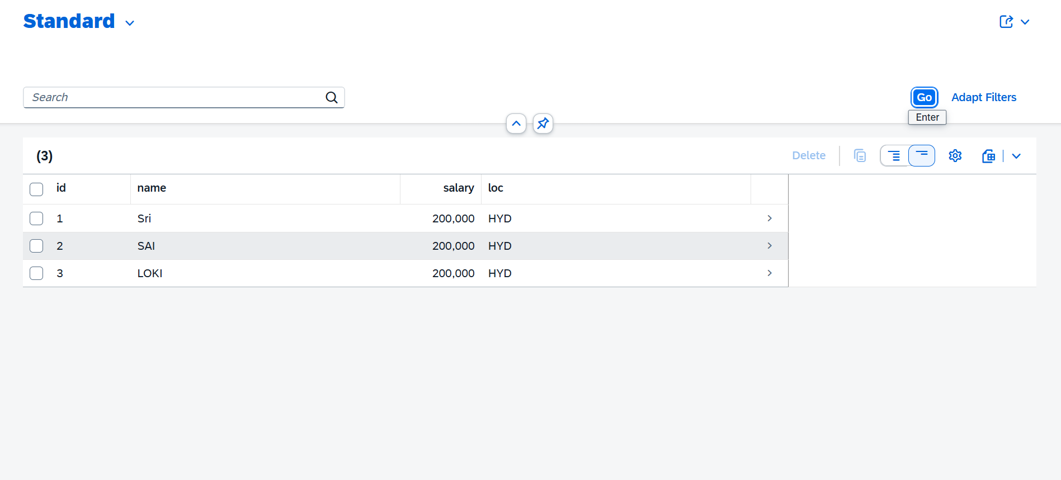
--Object Page
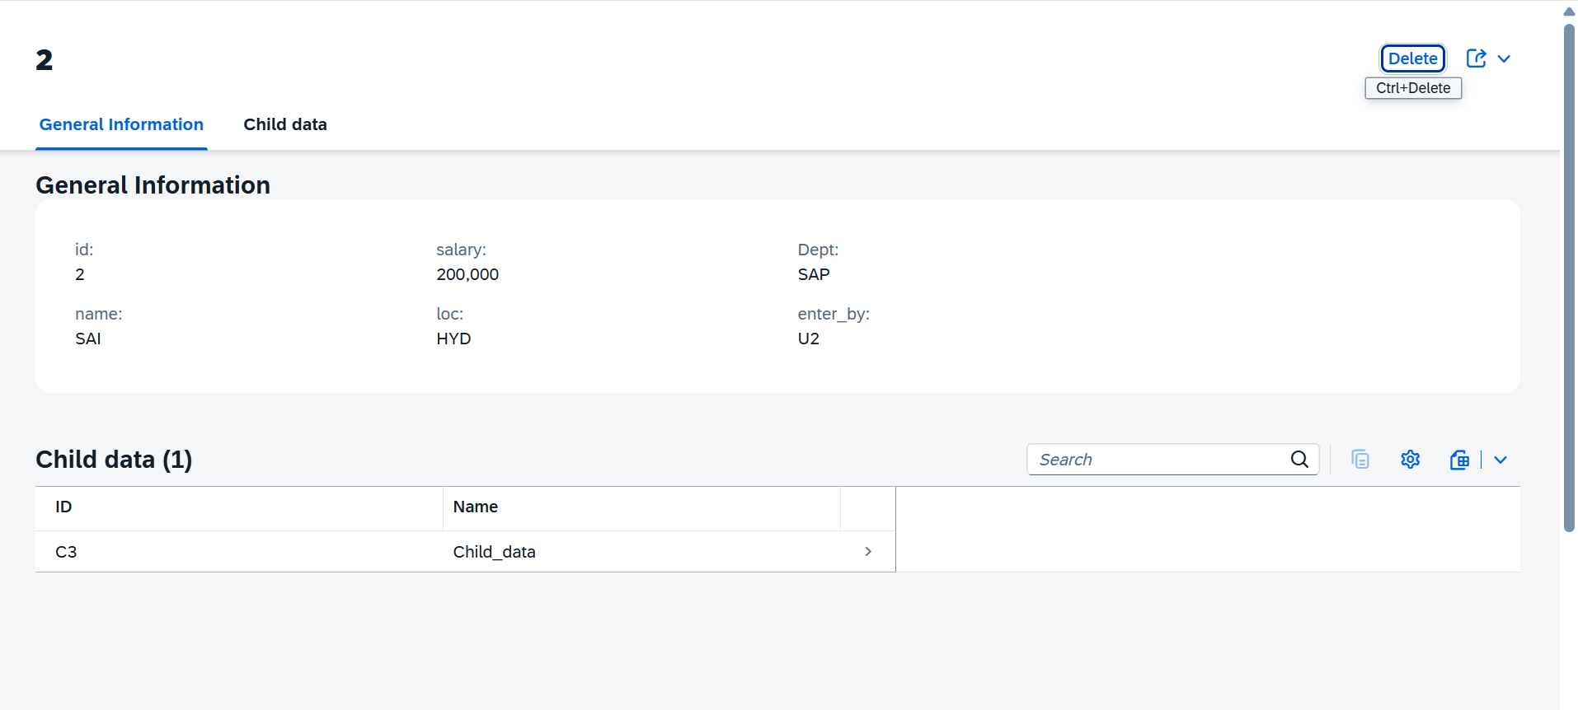

--3rd page
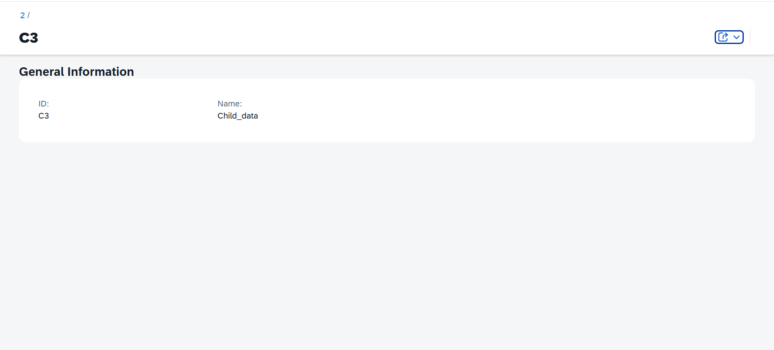

-Deployment Steps
- Cds add hana
- Cds add xusaa
- Cds add approuter
- Cds add mta
- Mta build -p cf
- Cf deploy mta_archives/*.mtar

By following the above steps, we can deploy the application after that we will go to the CI/CD

CI/CD

Subscribe to the Continuous Integration and Delivery in the BTP cockpit after that

Create a Credentials for the GIT-HUB (username and password of the GIT HUB account)
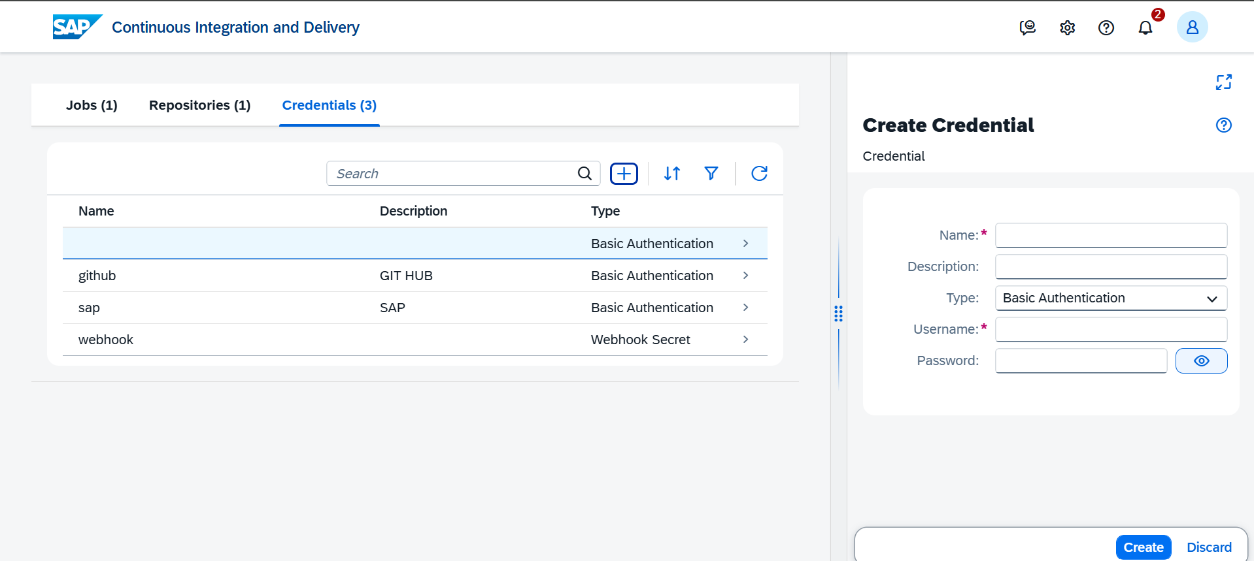
Create a Credentials for the BTP account (username and password of the BTP account)
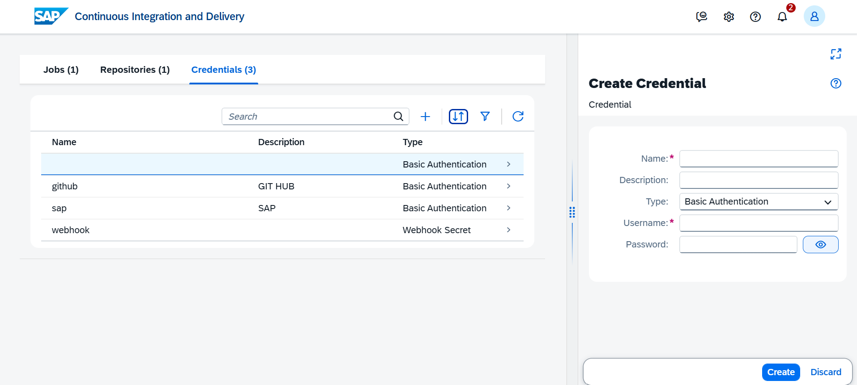
Create a webhook and copy that secret after generating it
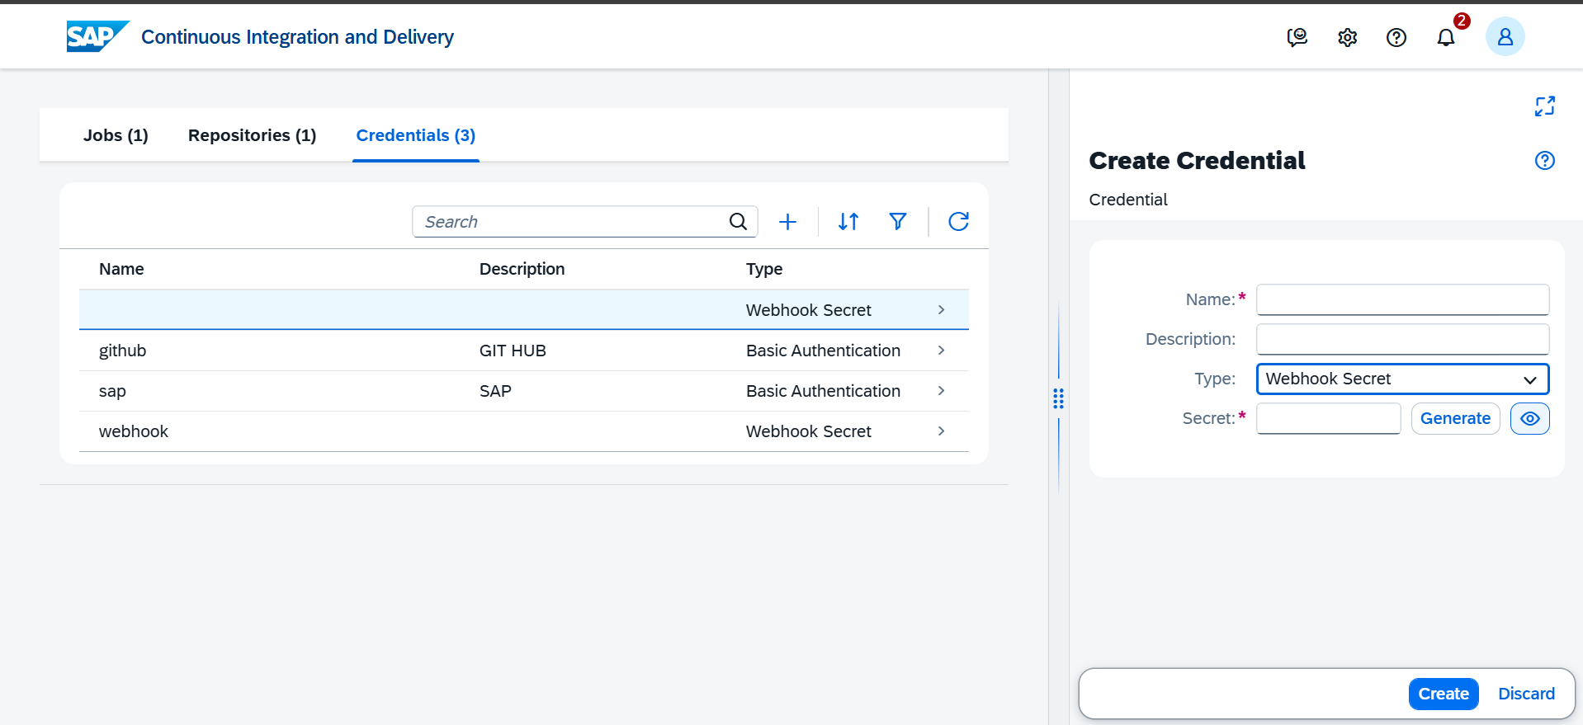

After the above steps are completed go to the Repositories section and create a new one where give your repo URL and the Credentials as the GUT-HUB one which we have created in the previous step 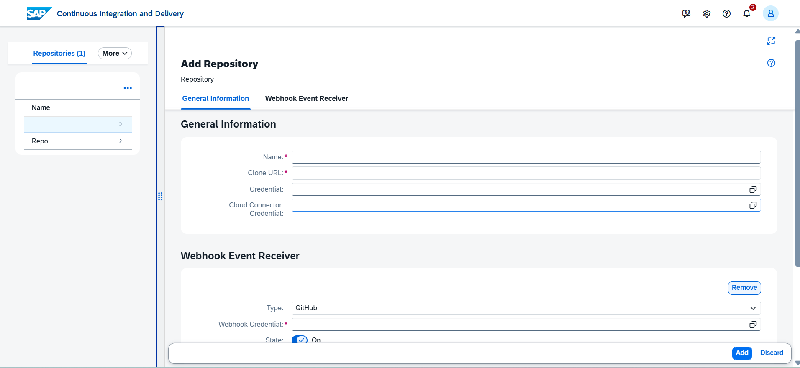

After that create a JOB for this where in the General info give your Repositorie (which was create in the previous step) and the branch as main

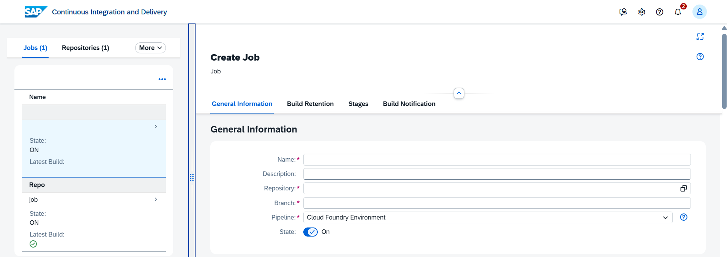

In the same window go do and give the Release which are your BTP cockpit endpoint, org name, space, and Credentials of the BTP account
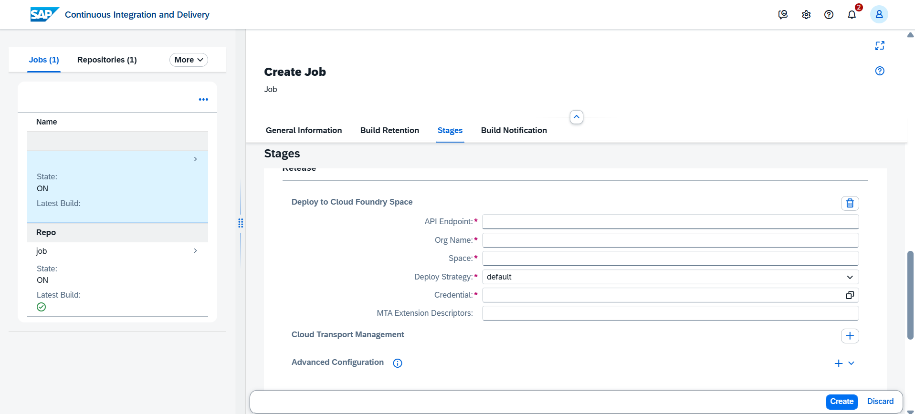

Open your git hub repository and go to webhooks in the settings and add the webhook
Where give the payload and secret which are coped from the above steps and the content type as the application/json
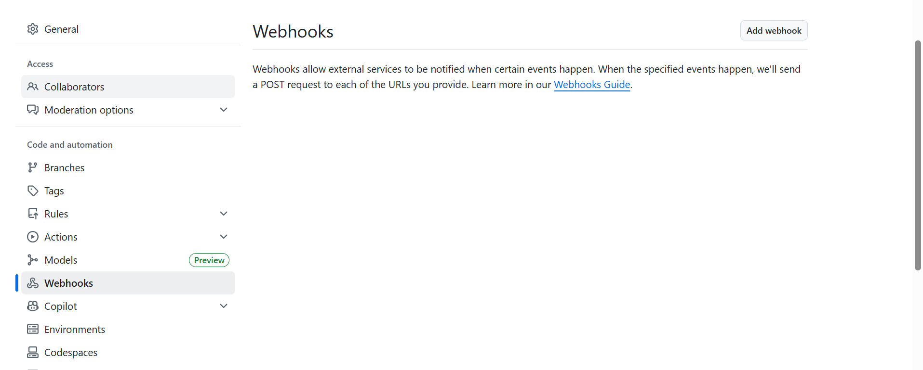

After everything done run the job if it Builds process completed without any errors your CI/CD pipeline is generated
